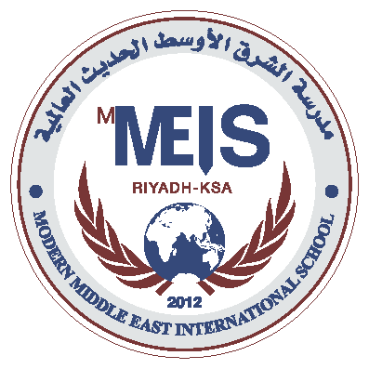
Modern Middle East International School
Syllabus for the Placement Test - UKG

ENGLISH:
Write in Sequence A-Z (Both Capital and small letter)
What comes after the given letter?
Circle the picture associated with the given letters.
Write the initial letter for the given picture.
Join the dots (Both Capital and Small Letters)

MATHS:
Write in sequence 1-100.
What comes after the given number (1-50)
Fill in the missing numbers at Random (1-50)
Count the pictures and match it to the correct number
Count the pictures and write the correct number in the box.

